LSUHSC nVision Reports Catalog

Business Unit: HCSDA
Report Description: Project List by BU
2-tier Layout: Project List.xnv
Web Layout: W Project List.xnv
Report Request: PROJ_LST
Web Report Request: WPROJLST
Dashboard Page/Button: Utilities/Projects by Business Unit
Report As of Date: Default from Business Unit or Specify last day of month

The report produces a listing of Projects by business unit. The report layout is built on the query PROJECT_BY_BU. The report displays the query fields: Setid, Project/Grant, Description, Total Budget, Pre-Encumbered, Encumbered, Expended, and Effective Date. The query is written on the PROJECT_ID_VW, ZZGL_TRANS_DTL, PROJECT_MGR, and PERSONAL_DATA tables. The query criteria prompt on Setid and Deptid. There is a second report request, PROJ_LIS that is available for use, but is not on the dashboard.

The web based report utilizes the query called WPROJECT_BY_BU that includes the additional table called ZZNVISIONPROMPT. The prompt criteria from the original query are replaced by an expression to enable web based prompting.

Report Example:
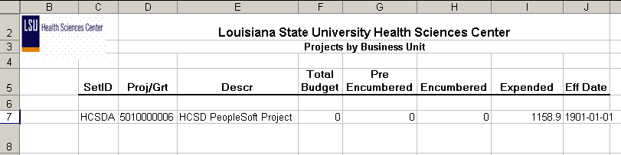
This report prompted on HCSDA setid and 2059340 department id.

Query Fields
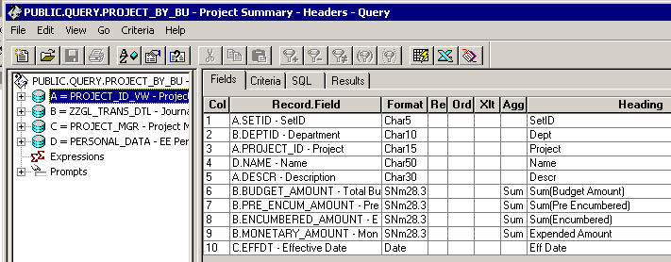

Query Criteria
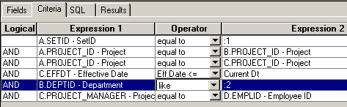

Web based Query Criteria
